LABORATORIO 2.1
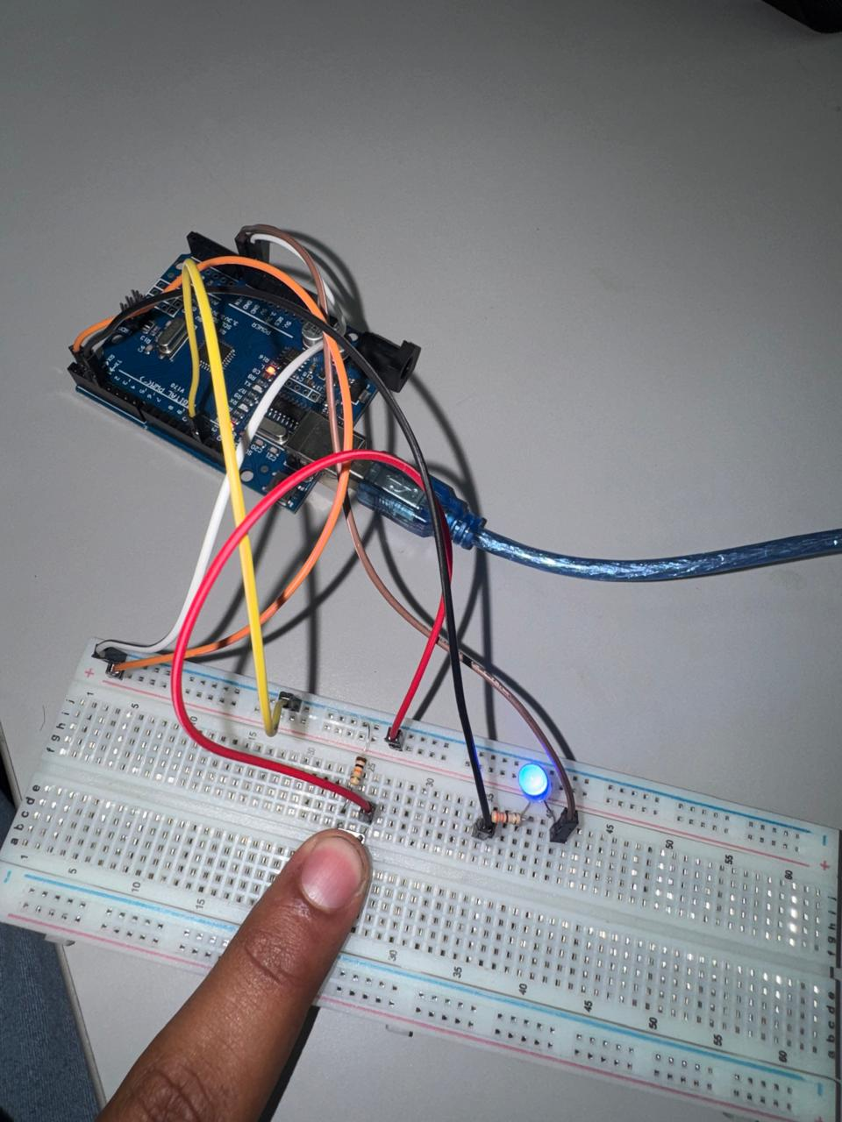

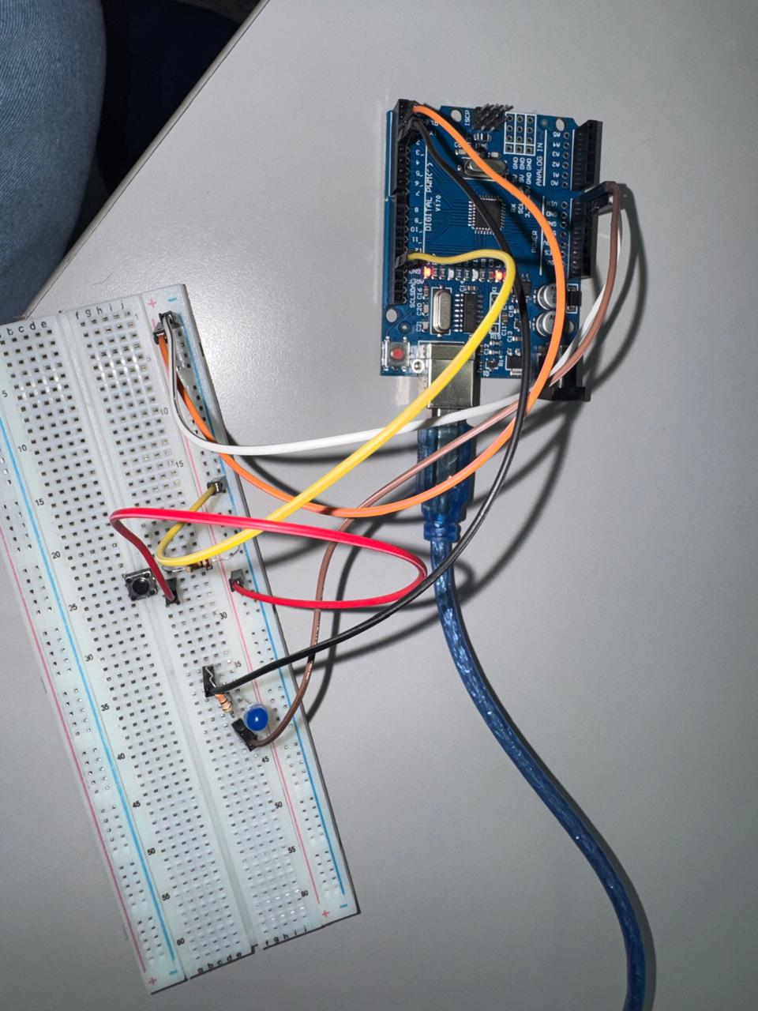
CODIGO
int PULSADOR = 2;
int LED = 3;

void setup() {
pinMode(PULSADOR, INPUT_PULLUP);
pinMode(LED, OUTPUT);

}

void loop() {
if (digitalRead(PULSADOR) == HIGH) {
digitalWrite(LED, HIGH);
} else {
digitalWrite(LED, LOW);
}
}

